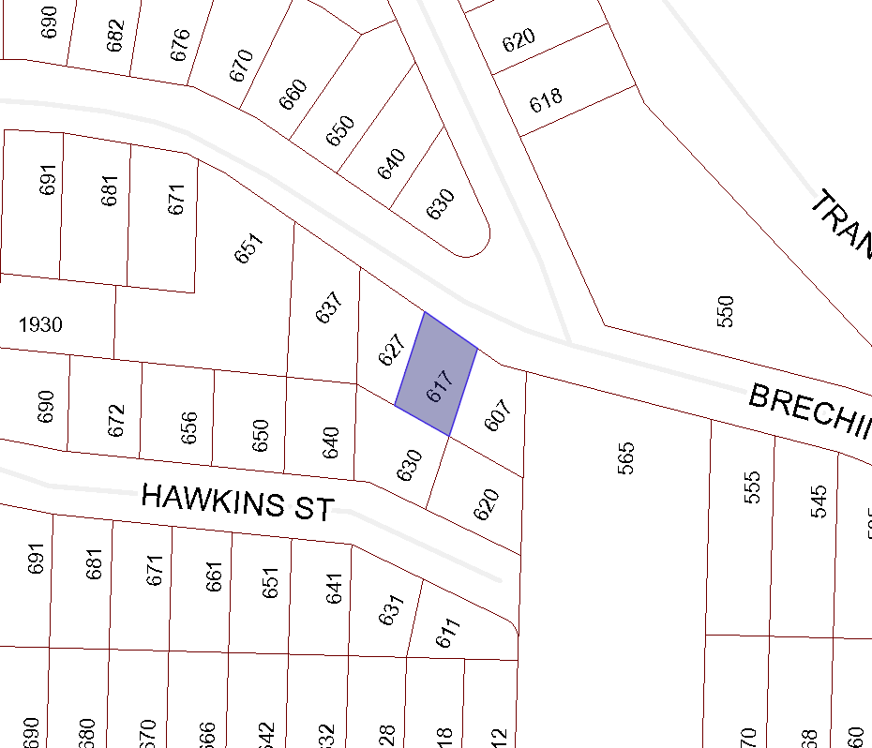

BOARD OF VARIANCE APPLICATION BOV00669

LOCATION MAP

CIVIC: 617 BRECHIN ROAD

LEGAL: LOT 2, SECTION 1, NANAIMO DISTRICT, PLAN 11467

